
Preparing for interviews
If you have an interview you will need to listen carefully and speak clearly.
It is a good idea to practise answers to common questions before you go to the interview.
One person should be the interviewer and ask the questions. The other person is the interviewee and answers the questions.
Question | Answer
What qualifications do you have?
What skills can you bring to this role?
Can you tell me a bit more about yourself?
Why should I offer you this job?

Each interviewer should write down the main points of the answers. If the interviewee has a CV, the interviewer can use it to check some of the answers. Are there any other questions you would ask?

Where do you see yourself in five years?

Be nice to live in a house with a garden, one with flowers in! And a big tree with a swing for the kids to play on.

Erm.. I meant in terms of work.

In an interview, you will usually be asked some ‘open’ questions and some ‘closed’ questions.

An open question cannot be answered ‘yes’ or ‘no’. Interviewers are usually looking for a longer answer. For example:

QUESTION: What did you enjoy about your last job?
ANSWER: I really liked dealing with customers, helping people and having lots of different
things to do. I was happy to be busy and liked being left in charge.

Interviews often start with open questions and move on to closed questions. A closed question has a short, specific answer such as ‘yes’ or ‘no.’ For example:

QUESTION: Do you have a full, clean driving licence?
ANSWER: Yes.
QUESTION: How long did you work at your last job?
ANSWER: Five years.

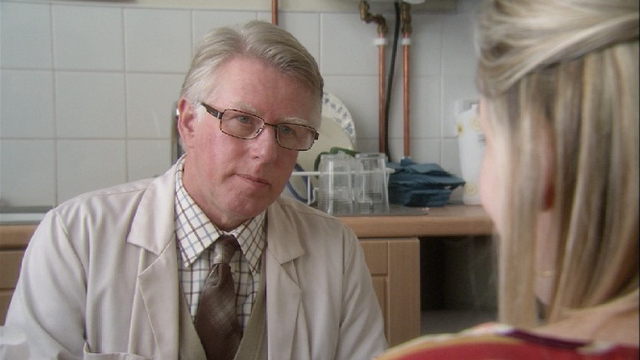In the BBC One drama Secrets and words, Valerie has an interview for a job in a chemist.
Interview questions
In the BBC One series Secrets and words, Valerie gets a job in a chemist. She doesn’t perform very well at interview but Ray still takes her on.

Factsheet E3

